DEEP TECH EUROPEAN VENTURE BUILDER COMPETITION 2026

Application Form
Please read the Call for Applications for the Deep Tech European Venture Builder Competition 2026 carefully to ensure you fully understand the terms and conditions before completing the application form below.

1. Applicant Details
Name of the company or university project:
Contact person:
Email Address:
Phone Number:
Affiliated De-TECH consortium university (select one appropriate box):
□ Estonian Business School
□ Istanbul Technical University
□ Leibniz University Hannover
□ Universidad Politécnica de Madrid

2. Eligibility Confirmation

How does your innovation relate to deep tech?
- Is your technology at TRL 4 or above? If yes, please describe how this level of readiness has been demonstrated. (E.g., lab testing, proof-of-concept results, pilot activities):
- Is your start-up De-TECH consortium university-affiliated? (If yes, please provide evidence (such as a registry output or confirmation from project coordinators from the participating university) confirming that the applicant meets one of the following criteria:
  - Employed as a researcher / faculty member or administrator
  - Enrolled as a graduate student
  - Founder of a start-up or spin-off established within the last five years, where the founding team not only included, at the time of establishment, but still includes academic/administrative staff, graduate students, or alumni who graduated within the past five years.

3. Project Description
Project Title:
Abstract - A brief, general description of the project (length: approx. 10 lines) intended for dissemination purposes. (Please ensure that this section contains only non-confidential information).
Project Summary (up to 5 pages) covering the following aspects that will be given equal weight in the evaluation:
- Innovativeness of the technology (scientific excellence and novelty — for guidance on matters related to “Intellectual Property & Confidentiality”, please refer to Section 4 below);
- Market relevance / social impact potential and scalability;
- Use case of the technology / Problem-Solution Fit;
- Maturity and feasibility for commercialization (e.g., realistic development plan, IP status);
- Team composition, capacity and commitment - incl. team members, relevant experience and expertise, their complementary and availability. Please provide a brief biography (maximum 4–5 lines or approximately 60–80 words) highlighting your educational and professional background, relevant experience in innovation or entrepreneurship, and your institutional affiliation. This information will be used for internal reference and dissemination purposes.

4. Intellectual Property & Confidentiality
Participants retain full ownership of their intellectual property. All applications and submitted materials will be treated with strict confidentiality and shared only with the members of the evaluation team, all of whom are bound by non-disclosure obligations. No technical or proprietary information will be publicly disclosed without the applicant’s explicit consent.
We are committed to supporting participants by facilitating tailor-made solutions between teams and mentors to address any IP-related concerns. At the same time, we strongly encourage applicants to consult at their university the Technology Transfer Office and/or their legal advisors to ensure appropriate intellectual property protection prior to and throughout the programme.

5. Agreement to Terms
I hereby confirm that the information provided in this application is accurate and complete to the best of my knowledge. I agree to the terms and conditions of the Deep Tech European Venture Builder Competition 2026 as stated in the call document.
Personal data collected via this form will be processed in accordance with EBS Privacy Terms and Cookies Policy.
Signature:
Date:

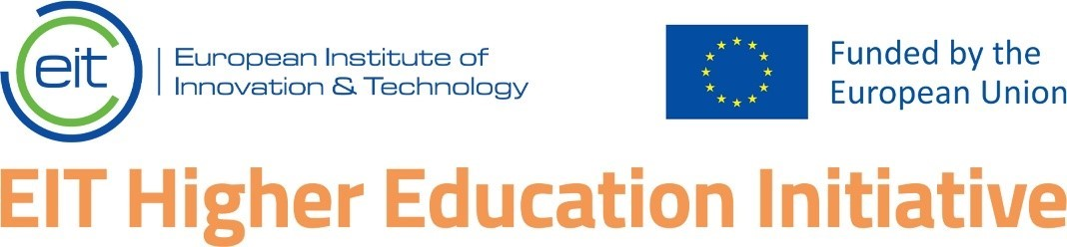 | The Deep Tech European Venture Builder Competition 2025 is funded by the European Union through the EIT’s Higher Education Initiative.

Both incorporated start-ups and unincorporated projects led by De-TECH consortium university-affiliated teams are eligible.
2 Universidad Politécnica de Madrid, Estonian Business School, Istanbul Technical University, or Leibniz University Hannover.

